**PART - 1 (Research Paper Exploration)**

**Summary**

The study titled "A Survey of Computer Architecture Simulation Techniques and Tools" by Akram and Sawalha aims to provide an in-depth overview of different simulation techniques and tools used in computer architecture research. The main goal of the paper is to classify various simulators, evaluate their accuracy and performance, and discuss the challenges and solutions related to computer architecture simulation.

To achieve this, the authors categorize simulators based on their simulation details, target scope, and input types. The paper covers a variety of simulators, including functional, timing, and hybrid simulators, and assesses their strengths and weaknesses. Additionally, the authors review different sampling methods and validation techniques to ensure the accuracy of simulation results. They also perform an empirical evaluation of six x86 simulators by comparing their outputs with real hardware runs. This comparison helps in understanding how well the simulators perform and how accurate they are under different microarchitectural configurations.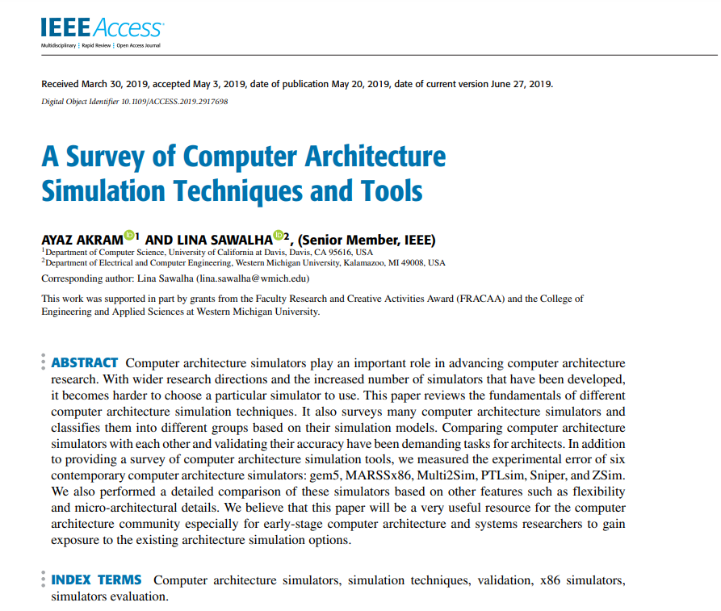

The document titled "A Survey of Computer Architecture Simulation Techniques and Tools" provides a comprehensive overview of various simulation techniques and tools used in computer architecture. It categorizes simulators based on detail (functional, timing, integrated), scope (full-system, application-level), and input (trace-driven, execution-driven). Specialized categories like multiprocessor/multicore simulators, energy and power simulators, and modular simulators are also covered.

The survey evaluates popular simulators such as gem5, MARSSx86, Multi2Sim, PTLsim, Sniper, and ZSim, comparing their features, accuracy, and simulation speed. Challenges like slow simulation and poor accuracy are addressed with solutions like sampled, statistical, and parallel simulation. The document also discusses validation techniques and provides experimental results comparing simulator accuracy and performance​

In summary, the survey provides a detailed evaluation of current computer architecture simulators, offering valuable insights into their accuracy, performance, and areas needing improvement. The authors advocate for the development of new simulation techniques to address the challenges presented by modern and future computing architectures.

**Critical Analysis**

Three major advantages of computing applications:

1. Modularity and Flexibility:

Modern simulators are built to be modular, meaning they can be easily customized and configured. This allows researchers to explore a wide range of architectural features and system interactions. For example, the gem5 simulator can be set up to support different Instruction Set Architectures (ISAs) and is useful for detailed experiments that involve both hardware and operating system interactions, or systems with various components like CPUs and GPUs.

2. Accuracy and Performance:

Simulators like Sniper and ZSim are known for their high accuracy and speed, especially when simulating many-core x86 architectures. These simulators have been tested and fine-tuned for specific architectures, which helps minimize errors in the simulation results. According to the paper, Sniper has the smallest error rate, making it very accurate, while ZSim is noted for being the fastest in single-core simulations.

3. Support for Full-System Simulations:

Simulators such as gem5 and MARSSx86 can perform full-system simulations. This means they can study applications that involve system calls and how the operating system interacts with hardware. This feature is particularly important for applications that frequently interact with the system, providing a more accurate depiction of real-world scenarios.

These advantages show that modern simulation tools are very flexible, perform well, and support comprehensive system studies, which are essential for advancing research and development in computer architecture.

**Two potential limitations:**

The study "A Survey of Computer Architecture Simulation Techniques and Tools" by Akram and Sawalha aims to give a clear overview of the different techniques and tools used in simulating computer architectures. It categorizes simulators, assesses their accuracy and performance, and discusses the challenges and solutions in this field.

Main Limitations of Computer Architecture Simulation

1. Long Simulation Times:

Simulating modern microarchitectures takes a long time due to their complexity and the length of today's programs, which often have billions or even trillions of instructions. This makes simulations time-consuming, sometimes taking from a few hours to several days for a single application. The issue is exacerbated in multiprocessor and multicore systems because simulators need to manage shared resources and synchronization. As benchmarks become more complex, simulation times increase even more.

2. Challenges with Accuracy:

Achieving accurate simulation results is difficult for several reasons. A major issue is the high number of branch predictor misses, which can significantly impact performance outcomes. Simulators also struggle to replicate certain micro-architectural features like µ-op fusion and µ-op cache, leading to inaccuracies. Furthermore, the high level of abstraction in some simulators and the lack of flexible reconfiguration options can result in errors in the simulation results.

Application of the Study's Methodologies and Findings to Course Activities

1. Project Selection and Planning:

When starting a project that involves simulating computer architectures, this survey helps students understand the different simulation tools available. By categorizing simulators based on detail, scope, and input types, students can choose the most suitable simulator for their project needs.

2. Simulator Evaluation and Validation:

The methods used in the survey to evaluate simulator accuracy can be applied to course projects. For example, if a project involves developing a new architecture or optimizing an existing one, students can use the validation techniques discussed to compare their simulation results with real hardware runs, ensuring their findings are reliable.

3. Hands-on Experimentation with Simulators:

The survey's empirical evaluation of six x86 simulators (gem5, MARSSx86, Multi2Sim, PTLsim, Sniper, and ZSim) can guide students in understanding how different simulators work under various conditions. By replicating these experiments, students gain practical experience and better grasp the strengths and limitations of each simulator.

4. Understanding Simulation Techniques:

The survey's detailed discussion on functional, timing, and hybrid simulators provides a solid theoretical foundation. This knowledge can be applied when designing experiments or simulations as part of coursework, ensuring that students select the appropriate level of simulation detail for their needs.

5. Addressing Simulation Challenges:

By identifying common sources of inaccuracies, such as branch predictor and cache misses, the survey helps students anticipate and mitigate similar issues in their projects. The proposed solutions can be integrated into their simulation strategies, leading to more accurate results.

6. Developing Innovative Simulation Techniques:

For advanced projects, students can explore the need for new simulation acceleration techniques, as highlighted in the survey. This could involve developing new methods or improving existing ones to manage the complexities of many-core architectures and heterogeneous design options.

7. Documentation and Modularity:

The survey emphasizes the importance of modular simulators with comprehensive documentation. This can guide students in structuring their projects, ensuring their simulation tools and techniques are well-documented and modular. This enhances usability and flexibility, benefiting future research and development efforts.

By incorporating the methodologies and findings from this paper, students can improve their understanding of computer architecture simulation and enhance the quality and reliability of their course activities and projects.

**PART -2 (Evaluating emulsiV)**

Overview

emulsiV is an advanced simulation tool designed to visualize and analyze emulsions, which are mixtures of immiscible liquids like oil and water. The primary purpose of emulsiV is to provide users with a detailed understanding of how emulsions behave under varying conditions. The simulation allows users to manipulate factors such as droplet size, concentration, and emulsifier type to observe their impact on emulsion stability and properties. By offering real-time feedback and visualization, emulsiV helps in optimizing formulations and understanding the complex dynamics of emulsions in various industries, including food, pharmaceuticals, and cosmetics.

**Advantages and Disadvantages**

Advantages:

1. I think emulsiV provides a dynamic and interactive platform for visualizing, which helps in better understanding and analysis of complex systems.

2. Here users can observe immediate changes in the emulsion’s properties as they adjust parameters, allowing for more optimization.

3. The tool offers detailed insights, stability, and phase behavior, which are crucial for developing and fine-tuning emulsion-based products.

Disadvantages:

1. Limited Scope: emulsiV may not cover all types of emulsions or scenarios, potentially limiting its applicability to specific contexts or industries.

2. Complexity: The advanced features and customization options might have a steep learning curve for new users, requiring time and effort to master.

Comparison with Traditional Tools

Compared to traditional tools like rheometers or centrifuges, emulsiV offers a more intuitive and visual approach to understanding emulsions. Traditional tools often provide static data or require physical samples, which can be time-consuming and less flexible. emulsiV, on the other hand, allows for real-time simulation and manipulation of virtual emulsions, making it easier to test different scenarios quickly. While traditional tools offer precise measurements and are essential for physical testing, emulsiV complements them by providing a broader and more interactive analysis environment.

Practical Application

For example:

A cosmetics company is developing a new facial cream that requires a stable emulsion to ensure consistent texture and effectiveness. The project aims to identify the optimal emulsifier concentration and droplet size for achieving the desired cream consistency and stability.

How emulsiV Enhances Outcomes:

EmulsiV would be used to simulate different formulations of the facial cream, allowing the team to visualize how varying emulsifier concentrations and droplet sizes impact the cream's stability and texture. By experimenting with these parameters in the simulation, the company can identify the best formulation without extensive physical testing. This approach accelerates product development, reduces costs, and enhances the likelihood of achieving a high-quality final product.

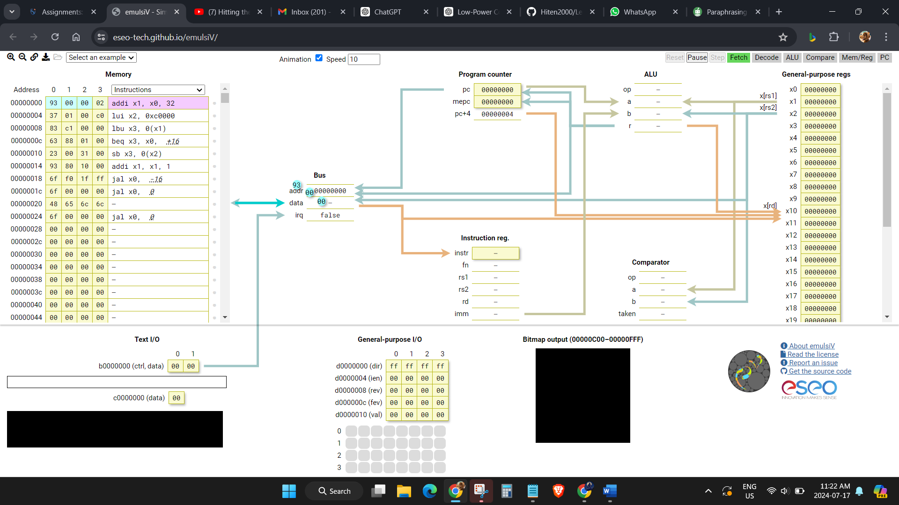

Sources:

* *IEEE Xplore Full-Text PDF:* (n.d.). <https://ieeexplore.ieee.org/stamp/stamp.jsp?tp=&arnumber=8718630>
* *emulsiV - Simulator for Virgule, a minimal processor based on the RISC-V architecture*. (n.d.). <https://eseo-tech.github.io/emulsiV/>